Unit Five Sources: 1865-1898 The Gilded Age/Industrialization
In the last few units I have been posting my answers to these documents as a way of modeling how to approach them. This week, I will post some SFI examples for each document, but that is it; I want to be sure nobody is just depending on my analysis without doing the heavy lifting themselves. If you have a particular question about any of the sources, feel free to post that question on my Schoology discussion board for clarification. If you have any additions to the SFI lists that I did not think of or put on there, please post it!
Unit II was very chronological. Unit III was not. Unit IV was very chronological. Unit V is not. (Unit IV will be both)
These sources are not in chronological order. For each source, provide the following:
I. Provide context of the source. Also consider POV, audience, purpose.
II. What is the nature of the source? Is the source religious, political, social, diplomatic, or economic and how so? Each source could be more than one; pick primary one.
III. List some (more than one) external SFI (specific factual information) relating to it AND EXPLAIN HOW IT APPLIES.
IV. For each source, create a thesis statement that used one of the three argumentation styles: cause/effect, compare/contrast, or continuity/change over time. For example:
If a source was a photo of Mother Jones, I might say: “There is a strong comparison between Mother Jones in the Progressive Era and those female reformers from the early 19th century in that she did not fit the Cult of Domesticity mold. A major difference, however, is that she operated in a time with a much more sophisticated media and was thus able to convey her message more effectively.”

I.
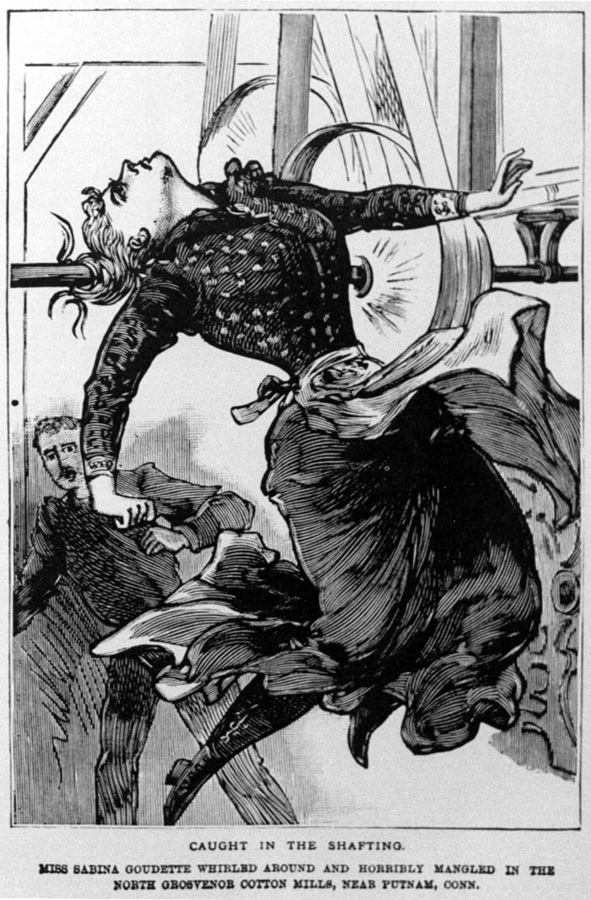SFI: Knights of Labor; AFL IW; W/Wobblies; socialism; unsafe working conditions; labor movement; laissez-faire

II.
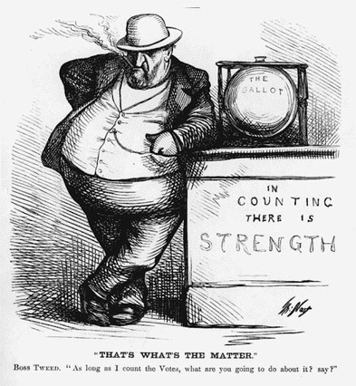 SFI: municipal corruption; Boss Tweed/Tammany Hall; Gilded Age; voting fraud

III.
“They saw even more ungodly things—the first zipper; the first-ever all-electric kitchen, which included an automatic dishwasher; and a box purporting to contain everything a cook would need to make pancakes, under the brand name Aunt Jemima’s. They sampled a new, oddly flavored gum called Juicy Fruit, and caramel-coated popcorn called Cracker Jack. A new cereal, Shredded Wheat, seemed unlikely to succeed—“shredded doormat,” some called it—but a new beer did well, winning the exposition’s top beer award. Forever afterward, its brewer called it Pabst Blue Ribbon.”
― Erik Larson, The Devil in the White City: Murder, Magic, and Madness at the Fair (1897) that Changed America
SFI: Gilded Age; industrial revolution; Edison/electricity/electric lights; emerging consumer market/economy; Westinghouse alternating current.

IV.
“Competition therefore is the law of nature. Nature is entirely neutral; she submits to him who most energetically and resolutely assails her. She grants her rewards to the fittest; therefore, without regard to other considerations of any kind…Such is the system of nature. If we do not like it and if we try to amend it, there is one way in which we can do it. We take from the better and give to the worse…Let it be understood that we cannot go outside this alternative: liberty, inequality, survival of the fittest; not-liberty, equality, survival of the unfittest. The former carries society forward and favors all its best members; the latter carries society downward and favors all its worst members.”
-William Graham Sumner, social scientist, The Challenge of Facts, 1882

SFI: Social Darwinism; Rockefeller/Standard Oil Company; ‘robber barons’/’captains of industry’; monopolies/trusts; Gilded Age; From Rags to Riches; laissez-faire
V.

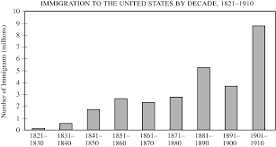

SFI: ‘New immigration’; nativism; Ellis Island; urbanization; tenements/slums; ‘scabs’/strikebreakers; Chinese Exclusion Act; Knights of Labor

VI.
“Article 2: The United States now solemnly agrees that no persons…shall ever be permitted to pass over, settle upon, or reside in…this reservation for the use of said Indians.

“Article 6: If any individual belonging to said tribes of Indians, or legally incorporated with them, being the head of a family, shall desire to commence farming, he shall have the privilege to select…a tract of land within said reservation, not exceeding three hundred and twenty acres in extent.

“Article 11: The tribes who are parties to this agreement hereby stipulate that they will relinquish all right to occupy permanently the territory outside their reservations…but yet reserve the right to hunt on any lands north of North Platte, and on the Republican Fork of the Smoky Hill river, so long as the buffalo may range thereon in such numbers as to justify the chase…They will withdraw all opposition to the construction of the railroads now being built on the plains…They will not attack any persons at home, or travelling, nor molest or disturb any wagon trains, coaches, mules, or cattle belonging to the people of the United States.”
-Second Treaty of Fort Laramie, agreed between the United States government and various band
of the Sioux nation, 1868

SFI: Plains Indian wars; reservation policy; assimilation policy; Carlisle Indian School; Dawes Act (1887); Wounded Knee/Ghost Dance (1890); buffalo extermination policies

VII.
Today we are raising more than we can consume. Today we are making more than we can use... Therefore we must find new markets for our produce, new occupation for our capital, new work for our labor... Ah! As our commerce spreads, the flag of liberty will circle the globe and the highway of the ocean - carrying trade to all mankind - will be guarded by the guns of the republic. And as their thunders salute the flag, benighted (ignorant) peoples will know that the voice of liberty is speaking, at last, for them... that civilization is dawning at last, for them.
--Senator Alfred Beveridge, 1898
SFI: NEED FOR MARKETS FOR OUR HUGE GROWTH IN INDUSTRIAL OUTPUT; imperialism; Spanish American War/President McKinley; USS Maine; Yellow-Journalism

VIII.

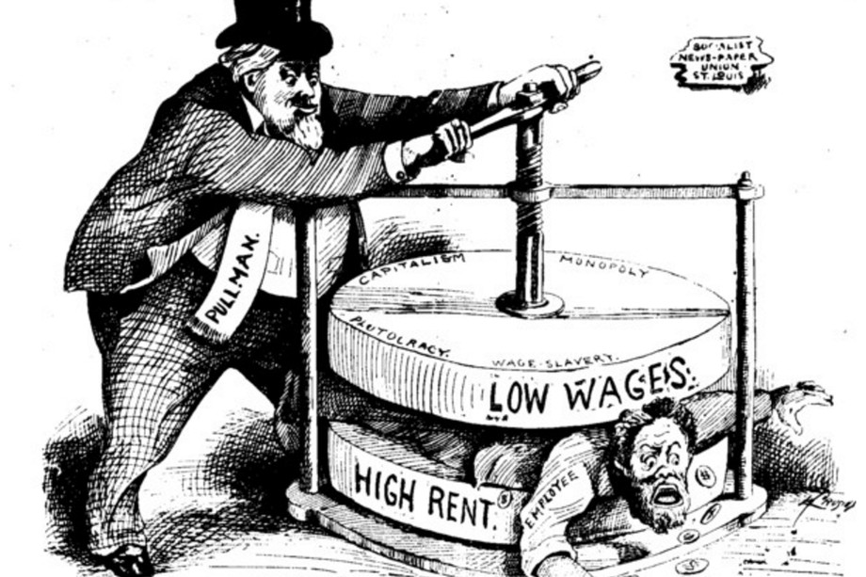
SFI: union movement; Pullman Strike; ‘company towns’; cycle of debt; Homestead Strike; scabs; Panic of 1893; child labor; Mother Jones; laissez-faire

VIII.
“So many people ask me what they shall do; so few tell me what they can do. Yet this is the pivot wherein all must turn.
“I believe that each of us who has his place to make should go where men are wanted, and where employment is not bestowed as alms. Of course, I say to all who are in want of work, Go West!...
“On the whole I say, stay where you are; do as well as you can; and devote every spare hour to making yourself familiar with the conditions and dexterity required for the efficient conservation of out-door industry in a new country. Having mastered these, gather up your family and Go West!”
--Horace Greeley, editor of the New York Tribune, letter to R. L. Sanderson, 1871

SFI: Manifest Destiny; westward movement; Plains Indians Wars; American Dream

IX.
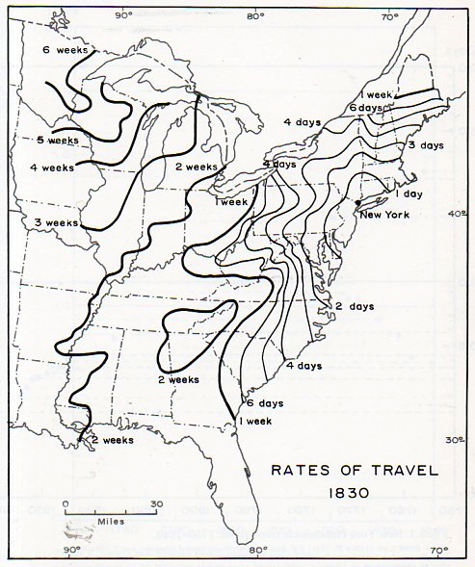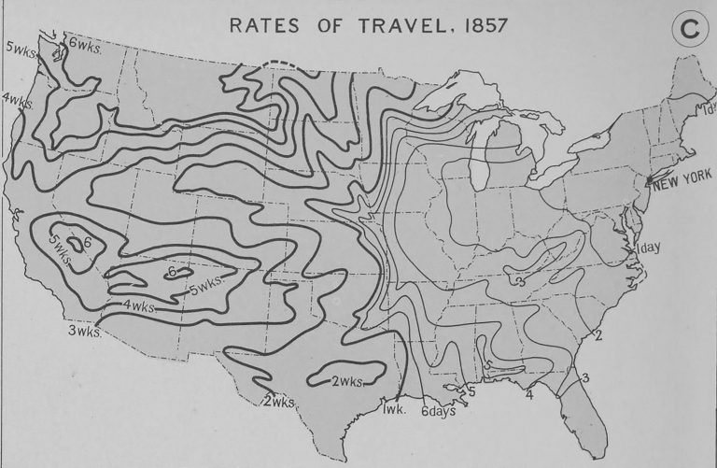
SFI: Railroad; steel industry/Bessemer Process; industrial revolution

X.
“In August 1865, the photographer Marcus Ormsbee... took a formal portrait of several groups of craft workers in their different shops. . . .A t the center of the photograph, at Outcault’s carpentry shop, stands the conventional artisan trio of master, journeyman, and apprentice, still at the heart of the city’s workshop world—yet class differences mark these craftsmen’s every feature.... Brooding above everyone, a new brick manufactory seals off its employees from the street and from public view. Small shop and large enterprise converge; New York remains a blend of old and new.”
Sean Wilentz, historian, Chants Democratic, 1984
SFI: Industrialization; end of artisan/rise of big national business; urbanization; labor movement

XI.
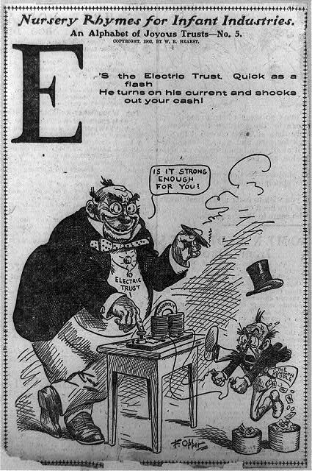
SFI: Gilded Age; monopolies/trusts; Standard Oil/Rockefeller; Social Darwinism; Sherman Anti-trust Act (1892); laissez-faire; Interstate Commerce Act (1887); ‘robber barons’

XII.
“It is found in the first place that the illiteracy test will bear most heavily upon the Italians, Russians, Poles, Hungarians, Greeks, and Asiatics, and very lightly or not at all upon English speaking emigrants or Germans, Scandinavians, and French. In other words the races most affected by the illiteracy test are those whose emigration to this country has begun within the last twenty years and swelled rapidly to enormous proportions, races with which the English speaking people have never hitherto assimilated and who are most alien to the great body of the people of the United States. On the other hand immigrants from the United Kingdom and of those races which are most closely related to the English speaking people, and who with the English speaking people themselves founded the American colonies and built up the United States, are affected but little by the proposed test. These races would not be prevented by this law from coming to this country in practically undiminished numbers.”
-Senator Henry Cabot Lodge, Address to the Senate, 1896
SFI: ‘New Immigration’; scabs; nativism/xenophobia; urbanization/tenements/slums; Chinese Exclusion Act (1882)

XIII.

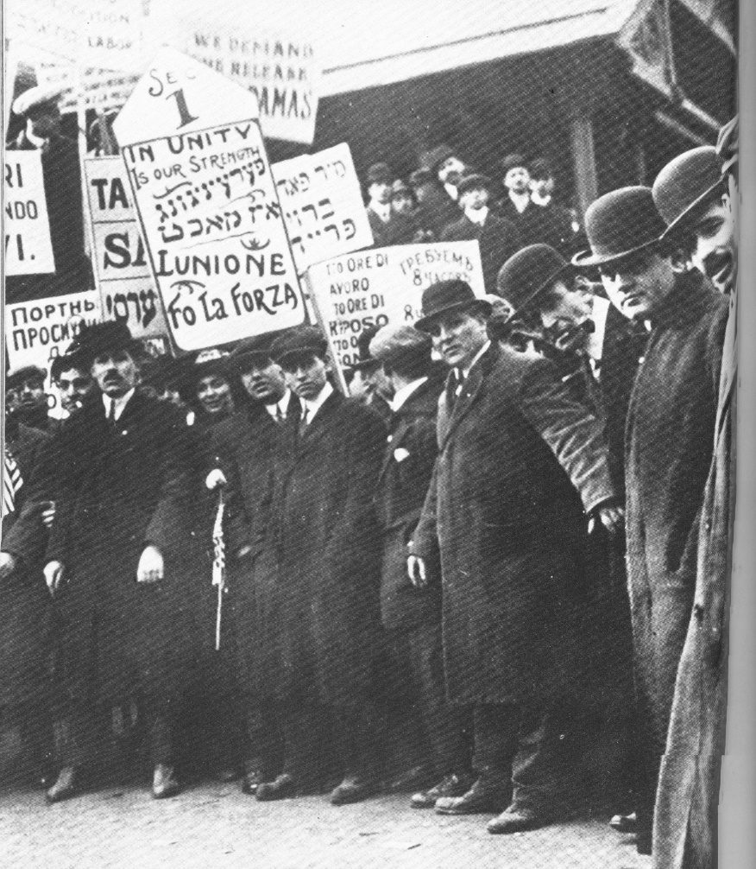
SFI: union movement; Knights of Labor; ‘New Immigration’; urbanization/slums; Homestead strike; Pullman Strike; Coxey’s Army
XIV.
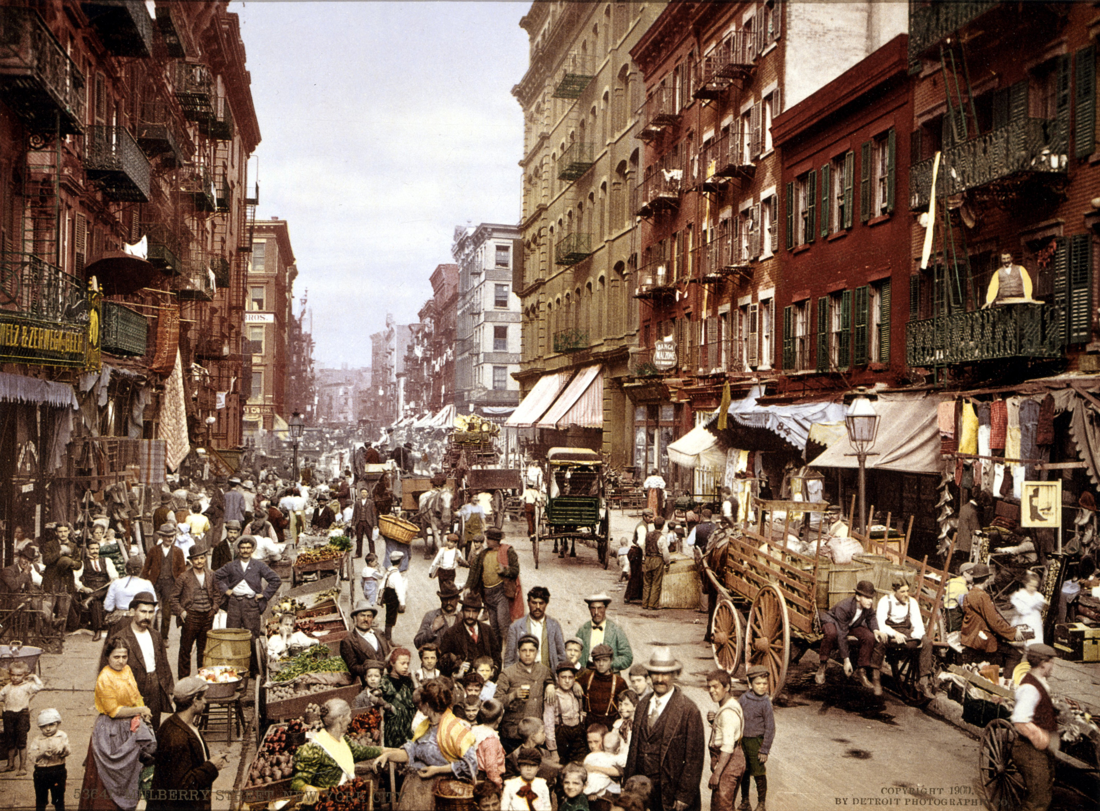
SFI: urbanization; ‘New Immigration’; slums/tenements; nativism/xenophobia
XV.
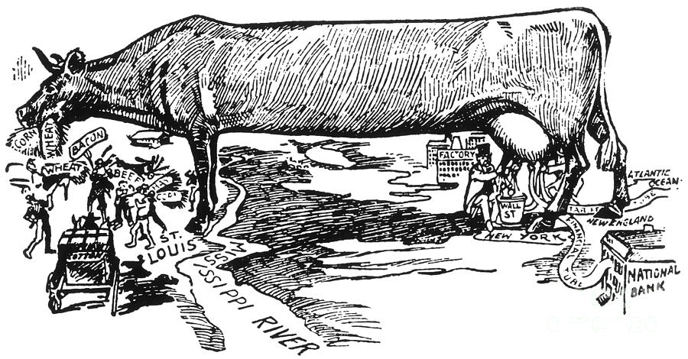
SFI: Populist Party/movement; ‘Cross of Gold’ speech/William Jennings Bryan; unfair shipping rates/Interstate Commerce Act; socialism; foreclosures; overproduction on farms; laissez-faire

